Solution Architecture
Date | 01 October 2026
Team ID | SWTID-2026-2351
Project Name | Auto Ticket Classification using Flow Designer
Maximum Marks | 5 Marks

Solution Architecture Diagram
The solution has a presentation layer (the form), a platform and access layer, an automation layer (Flow Designer) and a data layer (ServiceNow tables).
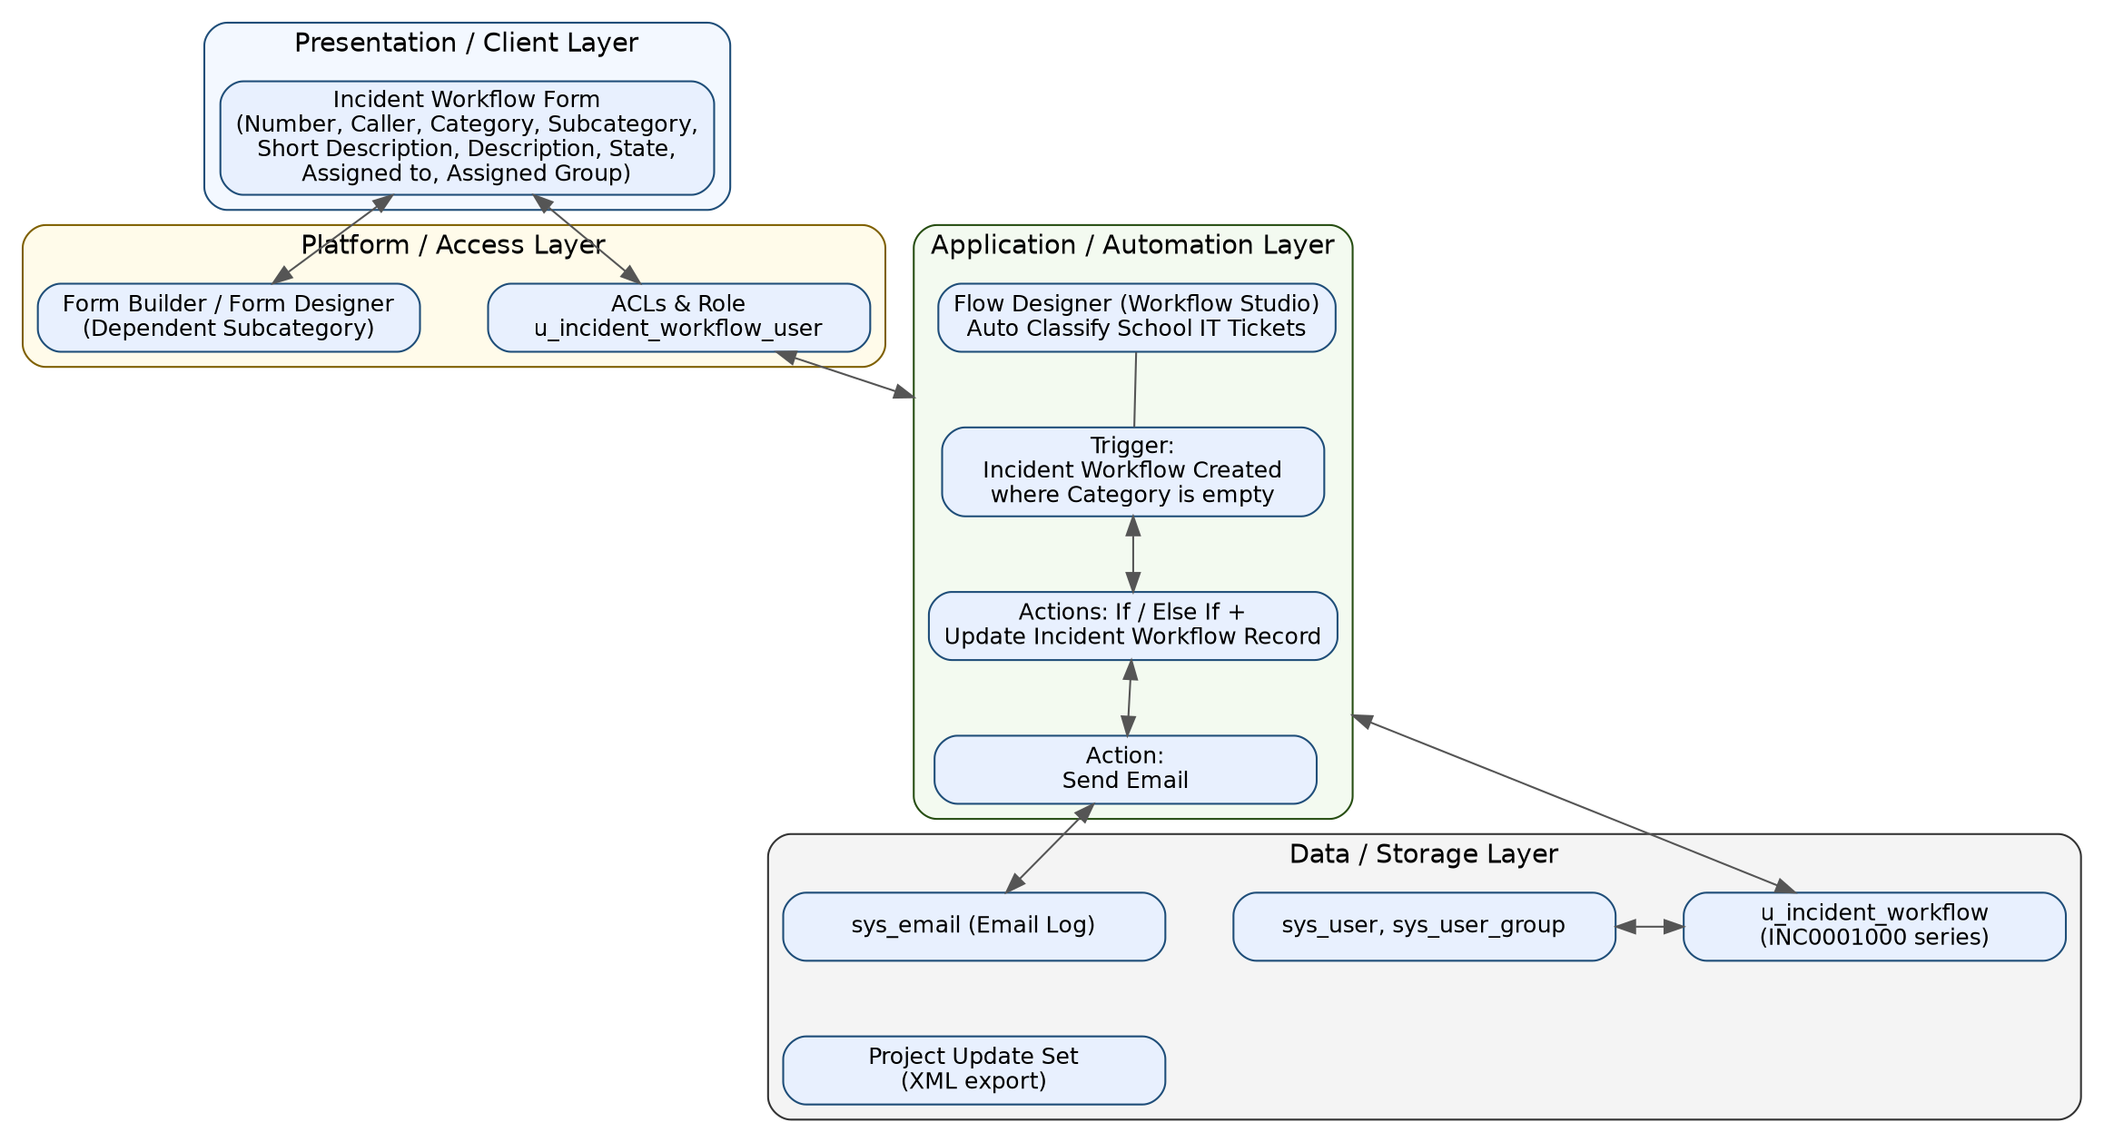
Figure 1: Solution architecture of Auto Ticket Classification

Component Description Table
Component Name | Description / Role in Architecture | Technologies Used
Presentation Layer | Incident Workflow form where callers enter Caller, Short Description, Description and where staff set State, Assigned to and Assigned Group. | ServiceNow Form Builder / Form Designer
Access Control | Restricts the table to users with the u_incident_workflow_user role. | ServiceNow ACLs and roles
Automation (Flow) | Flow "Auto Classify School IT Tickets" triggers on record creation with empty Category, classifies with If / Else If and updates the record, then sends the email. | Flow Designer (Workflow Studio)
Notification | Sends the confirmation email to the caller and logs it. | Send Email action, sys_email
Database | Stores tickets, users and groups. | u_incident_workflow, sys_user, sys_user_group
Deployment / Transfer | Packages configuration in an Update Set and exports it to XML. | Update Sets

